Packet Loss Tool User Guide
Contents
Packet Loss Tool User Guide 1
1. Introduction 2
1.1 Overview 2
2 Getting Packet Loss Tool 3
2.1 Plastic Release Repo 3
3 Configuring Packet Loss Tool 3
3.1 Config File 3
4 Using Packet Loss Tool 5
4.1 Basic Usage 5
5 Glossary 7

1. Introduction

1.1 Overview

1.1.1 Purpose of this document and intended audience
This document, called the Packet Loss Tool User Guide, is both an usage guide and an reference guide. This guide is for APTIV Internal users, offering full step-by-step usage, configuration instructions and support areas.

1.1.2 Steps to take
In order to be able to use Packet Loss Tool, you must first have a Windows or Linux Environment.
The first step, illustrates getting Packet Loss Tool from Plastic Resim Release Repo Binaries onto your computer. The second step, shows how to customize a Packet Loss Tool with Config Files depending on your individual needs. The final step, covers the specific steps you can take to get the Packet Loss Tool application to run.

1.1.3 Quick start
The process of Getting and Running Packet Loss Tool can be summarized as follows:
- For the casual or new user the simplest way is to get a Binaries from Plastic Release Repository.
- Configure depending on your individual needs.
- Run Packet Loss Tool using below command
For Binaries :
MUDP_Log_DataExtracter.exe “path/to/MUDP_DATA_Extracter_config.xml” “path/to/f_list.txt” “path/to/files to be generated ”
MUDP_Log_DataExtracter.exe “path/to/MUDP_DATA_Extracter_config.xml” “path/to/json” “path/to/files to be generated”
For Docker :
./GEN_LOG.sh /input/MUDP_DATA_Extracter_config.xml “path/to/MUDP_DATA_Extracter_config.xml” “path/to/json” “path/to/files to be generated”

./GEN_LOG.sh /input/MUDP_DATA_Extracter_config.xml /input/BMW_fList.json /input/OUTPUT_DIR

1.2 What is Packet Loss Tool?

1.2.1 Operating System
Different software programs are designed for different operating systems, and most won't work on systems that they weren't designed for. Packet Loss Tool is Supported on Both Windows and Linux Operating System.

1.2.2 What is Packet Loss Tool, and how can it help me?
Packet Loss Tool can be used to analyze list of logs. Packet Loss tool would generate XML or txt based report for log analysis.
Packet Loss Tool report would give following information from the log-
- Log name
- Report Generation time
- CS Number
- Packet Loss Summery
  - Bad log scenarios

2 Getting Packet Loss Tool

2.1 Plastic Release Repo
By far the easiest way to get Packet Loss Tool is from Plastic Resim Release Repo. Always move to the latest Change set to have the updated version of Packet Loss Tool. These packages contain ready-to-run binary files specifically compiled in release mode for distribution, and they are tested regularly by the developers for both functionality and completeness.
We have made package easily available at
RESIM Release repository Details-
Repository: "10028634_01_SRR_RESIM_Release@plasticscm_prod1.delphiauto.net:8087"
Latest Change Set.
Path: 10028634_01_SRR_RESIM_Release\RESIM_Toolset\MUDP_LogData_Extractertool\BMW_Releases

3 Configuring Packet Loss Tool

3.1 Config File
Packet Loss Tool can be configured using MUDP_DATA_Extracter_config.xml.
MUDP_DATA_Extracter_config.xml contains XML attributes to configure following items-
- Setting Report Output path

- To Generate XML based Packet Loss Report, use “Data_Extraction_Mode” and set “Log_Quality_Summary” to 1.
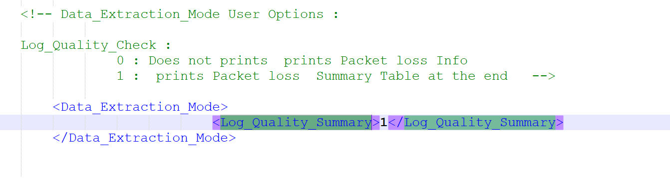

4 Using Packet Loss Tool

4.1 Basic Usage
This section will describe all aspects of using Packet Loss Tool, such as running executables, command line parameters, Reading the report, etc.
You can use Packet Loss Tool with following command:
Usage: ./GEN_LOG.sh /input/MUDP_DATA_Extracter_config.xml /input/BMW_fList.json /input/OUTPUT_DIR
Run the program

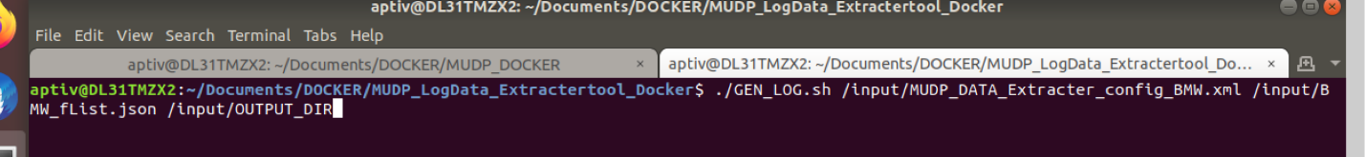

Logs is parsed and parsed details are captured in the packet loss report. Once the packet loss information is extracted, user would be notified with success or failure message.

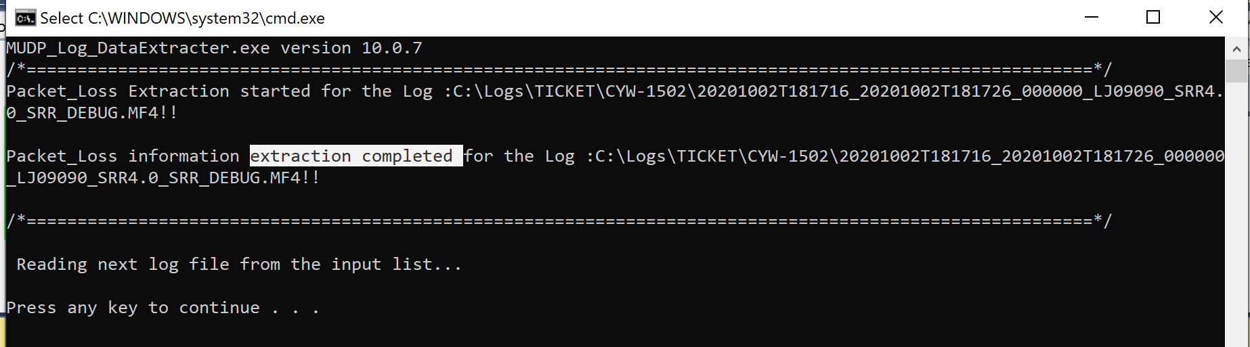

Report will be generated with name- “Data_Logging_Quality.xml”.

This report would contain following information all sensor data in the log-
  - Log name
  - Report Generation time
  - Packet Loss Summary

5 Glossary
Binary
A file which is in machine executable, compiled form: hex data.
DLL
A DLL (Dynamic Link Library) is a file that can be loaded and executed by programs dynamically.
Terminal
A terminal window is usually a command line window that one uses to execute a command.

